1. Project Proposal
1.1 Introduction

1.1.1 Current Issues
At University Malaysia Pahang Al-Sultan Abdullah (UMPSA), students often face difficulty in accessing structured, high-quality learning materials outside regular class hours. Most online learning content depends entirely on individual lecturers’ efforts–some may upload videos or notes on external platforms like YouTube, while many others do not. As a result, students who wish to revise lessons, explore new topics, or learn additional skills beyond their coursework have limited options.
The lack of a centralized e-learning platform within the university limits opportunities for self-paced learning, knowledge retention, and continuous academic development. This also affects the quality of the learning experience, as materials are scattered, unorganized, and inconsistent across courses and lecturers.
Our focus in this project is therefore on improving the software quality attributes such as usability, reliability, and maintainability, ensuring that the platform provides a consistent, easy-to-use, and dependable environment for learning. The goal is not only to build functional software but also to ensure that its quality meets the expectations of both students and lecturers.

1.1.2 Objective of study
The objective of this study is to develop a functional and user-friendly e-learning platform called Ez2Learn, designed to simplify the learning experience by providing an accessible and interactive online environment. Inspired by Coursera, the system allows users to learn new skills, explore various subjects, and earn completion certifications in one centralized platform. Ez2Learn consists of four main modules: User Management, Learning Materials Management, Assignment Management, and Progress Tracking. The study focuses on creating an intuitive interface with easy navigation to enhance user engagement and learning efficiency. In addition, emphasis will be placed on ensuring system responsiveness, data security, and scalability to support future improvements. This research aims to provide valuable insights into the development of a simplified and effective e-learning system that encourages continuous learning and skill development in a digital setting.

1.1.3 Project to be developed (Ez2Learn)
The Ez2Learn project is a modern and user-friendly e-learning platform developed to address the growing challenges faced by university students in accessing quality online learning materials and structured courses outside of regular class hours. In many academic environments, including Universiti Malaysia Pahang Al-Sultan Abdullah (UMPSA), there is currently no centralized system that offers flexible online courses, video lectures, quizzes, and certification for self-paced learning. Ez2Learn aims to bridge this gap by providing an organized, interactive, and easily accessible digital learning environment where students can explore new subjects, acquire skills, and learn at their own pace.
The system is designed with inspiration from popular online learning platforms such as Coursera, but tailored to suit the needs of university students and educators. It will serve as a centralized learning hub where users can browse courses, access lecture materials, complete assignments, and monitor their learning progress. Through its intuitive and responsive interface, Ez2Learn ensures that users can seamlessly navigate between modules, view learning content, and track performance with minimal effort. The platform’s structure emphasizes accessibility and engagement, allowing students to take control of their learning experience anytime and anywhere.
One of the core strengths of Ez2Learn lies in its four main modules: User Management, Learning Materials Management, Assignment Management, and Progress Tracking. The User Management module enables administrators to manage user accounts and assign appropriate roles for students and instructors. The Learning Materials Management module allows instructors to upload video lectures, notes, and supplementary materials that students can easily access. Meanwhile, the Assignment Management module provides tools for creating, submitting, and grading assignments in an organized manner. Lastly, the Progress Tracking module helps both students and instructors monitor learning outcomes, quiz results, and completion statuses, ensuring transparency and motivation for continuous improvement.
To promote effective online learning, Ez2Learn will integrate interactive features such as quizzes, discussion forums, and completion certificates. These features not only encourage active participation but also help students showcase their achievements. Furthermore, the platform will prioritize responsiveness, security, and scalability, ensuring a smooth user experience across devices while protecting user data.
Ultimately, the Ez2Learn project aims to become a comprehensive and sustainable digital learning solution that supports both academic and personal growth. By creating a centralized platform that simplifies access to learning materials and supports flexible, self-paced education, Ez2Learn seeks to enhance the quality of online learning at UMPSA and inspires a culture of lifelong learning among students.

1.2 Problem Statement
At Universiti Malaysia Pahang Al-Sultan Abdullah (UMPSA), many students struggle to access well-organized and reliable learning materials outside of their regular classes. Most resources are shared through different platforms like Google Drive, YouTube, or personal lecturer pages, which makes it difficult for students to keep track of what they need. Because everything is scattered, students often waste time searching for notes or lecture videos instead of focusing on learning. Without a single, centralized system, studying becomes less convenient and harder to manage, especially for those who prefer to revise or learn at their own pace.
Another issue is the inconsistency in how lecturers share materials. Some lecturers upload complete sets of notes and video lectures, while others only share minimal content or none at all. This unevenness means that some students have access to plenty of resources, while others are left behind. It creates an imbalance in learning opportunities and affects how well students can prepare for exams or explore new topics independently.
Lastly, learning outside the classroom often feels one-sided and less engaging. Since there is no proper e-learning platform, students have fewer chances to take part in interactive learning activities such as quizzes, discussions, or self-assessments. Lecturers also find it hard to monitor students’ progress or give timely feedback. As a result, many students lose motivation, and their learning experience becomes less effective.

1.3 Background of Project
In recent years, online education has transformed how students access knowledge and develop new skills. Global e-learning platforms such as Coursera, Udemy, and edX have set a new standard for flexible, self-paced learning. However, most universities–including Universiti Malaysia Pahang Al-Sultan Abdullah (UMPSA). Still lack an internal system that offers similar functionality tailored to their students’ needs.
Currently, UMPSA students depend heavily on traditional classroom teaching or informal resources shared through messaging apps and scattered links. While this may work for routine coursework, it limits students who wish to study independently, revise lessons, or learn additional subjects beyond their syllabus. This lack of a centralized, high-quality online learning environment inspired the development of Ez2Learn.
Ez2Learn is designed as a comprehensive yet simplified online learning platform that combines the essential features of global learning systems with the specific requirements of UMPSA students and lecturers. It focuses on quality, accessibility, and ease of use, ensuring that learning can happen anytime, anywhere.
Main features of Ez2Learn:

  - User Management System
    - Three types of users: Admin, Lecturer, and Student.
    - Secure registration and login for all users.
    - Admins manage roles, content approvals, and account maintenance.
  - Course Management
    - Lecturers can create, edit, and manage courses.
    - Each course can include video lectures, reading materials, and quizzes.
    - Students can browse available courses and enroll with one click.
  - Video lecture library
    - High-quality instructional videos uploaded by lecturers.
    - Students can stream or re-watch content at their own pace.
    - Video playback history and progress tracking ensure continuity.
  - Interactive Quizzes and Assessments
    - Each course includes auto-graded quizzes to test understanding.
    - Students receive instant feedback and can review incorrect answers.
  - Certificate of Completion
    - Upon completing all modules and quizzes, the system automatically generates a digital certificate.
    - Certificates can be downloaded or shared on professional platforms such as LinkedIn.
  - Progress Tracking Dashboard
    - Personalized dashboards for students showing completed courses, scores, and ongoing progress.
    - Lecturers can monitor student performance and participation levels.
  - Quality and Usability Focus
    - Emphasis on software quality assurance, ensuring that all components are reliable, user-friendly, and maintainable.
    - Usability testing and continuous feedback will help refine the interface design, loading performance, and content delivery.

1.4 Development Methodology

1.4.1 Method of development

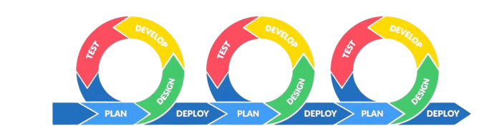
For the development of Ez2Learn, our team has chosen to follow the Agile Scrum methodology. One of the most adaptable and useful methods for software development is scrum, especially for student projects where collaboration, communication, and incremental improvement are essential [1].
Instead of building the whole system at once, we will develop, test, and improve each part step by step. This approach allows us to adapt easily if any issues or new ideas come up during the process. This method will keep us on track, improve our productivity, and guarantee that our system is getting better with each iteration. It also encourages regular team discussions and updates, which makes problem-solving faster and helps maintain good coordination between members [2].
Additionally, Scrum supports continuous testing, feedback, and improvement throughout the development cycle, which matches the principles of Software Quality Assurance (SQA). Each sprint includes evaluating and improving the features to identify and resolve problems early instead of waiting until the end to test the system. This helps improve the system’s usability, reliability, and maintainability, which are the key goals of the Ez2Learn project

1.5 Module

Module 3: Manage Assignments & Assessments
The Manage Assignments & Assessments module goal is to help both lecturers and students handle course tasks easily and efficiently. It gives lecturers an easy way to develop and manage assignments or quizzes, while students can submit their work, check deadlines, and review their results in a single platform.
Create:
Lecturers can create new assignments or quizzes for their courses and add important details like the title, description, due date, and total score. They can also upload important materials such as instructions or test questions for tests or an assignment. When a lecturer creates a new task, it automatically appears in the student’s dashboard and makes it easy for students to know what needs to be done.
Read:
Students can view all their assignments, deadlines, and marks in an orderly list. Also, they can read the instructions on the platform or download the files. While instructors may see all the assignments they created, monitor student's work, and grade every assignment.
Update:
Lecturers may need to make changes after an assignment has been created. They can edit information like the due date, grades, and even upload new files. Students can also update their submission before the deadline if they want to upload a revised version. This ability to change ensures that there won't be any misunderstandings or technological issues when both sides manage their tasks.
Delete:
Lecturers can remove old or unnecessary assignments to keep their course page tidy. Administrators also have permission to remove any duplicate or invalid entries to maintain system quality. When something is deleted, the system ensures that related data, such as student submissions and so on, are properly handled or deleted to keep the platform clean and secure.

1.6 Expected Outcome
It is expected that the Ez2Learn platform will provide a reliable, secure, and easy to use online learning platform that will help both lecturers and students at Universiti Malaysia Pahang Al-Sultan Abdullah. By the end of this project, the team aims to develop a functional web based system that supports essential teaching and learning activities with its four primary modules: Assignments & Assessments, Learning Materials Management, User Management, and Progress Tracking.
It will be expected that the system will make it simple for students to access course materials, finish assignments, and track their progress in an efficient way. At the same time, lecturers will be able to manage courses, upload content, and evaluate student performance more easily. To ensure that all data, including user information, submitted materials, and assessment records, can be created, read, updated, and removed without any problems, the platform will also have basic CRUD functionalities.
The project aims to create a system that offers high quality of usability, dependability, maintainability, and security in terms of software quality. The user interface will be responsive and easy to use, ensuring uninterrupted device navigation. The team also expects to gain valuable experience in applying software quality assurance practices such as documentation, testing, and version control throughout the development process.
Overall, the expected outcome of this project is not only a functional e-learning system but also a representation of how strong cooperation and quality assurance concepts can support the creation of a sustainable beneficial digital learning platform.

1.7 Prototype

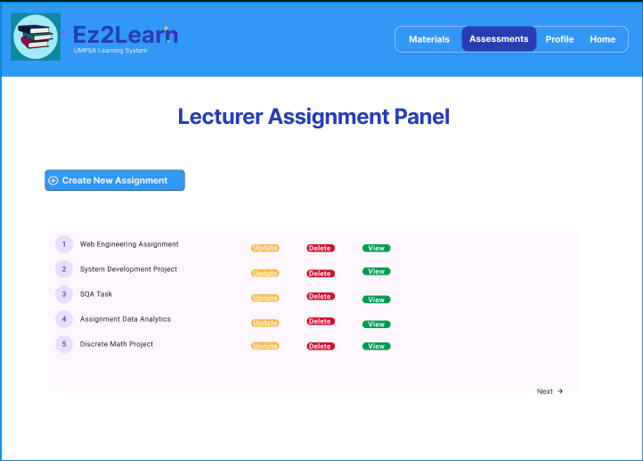
This module allows lecturers to easily manage all course assignments in one place. They can create new assignments, update existing ones, delete outdated tasks, or view detailed submissions.

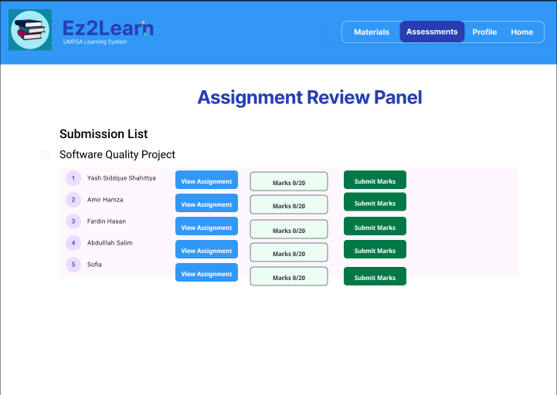
This module enables lecturers to review student submissions efficiently. It displays a clear list of all students who have submitted their assignments, along with options to view the submitted work, assign marks, and submit grades directly.

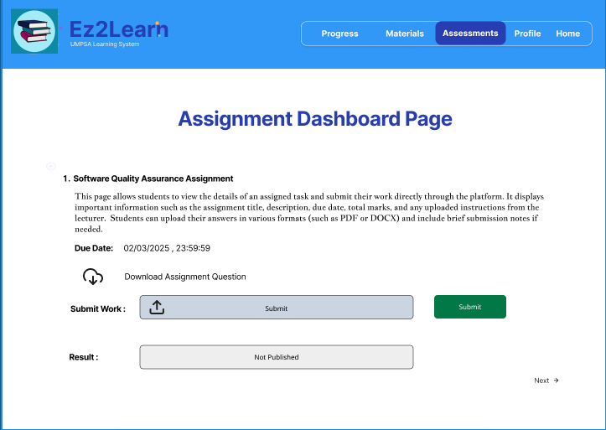
Students may access all the tasks that their lecturers assigned to them in this module, including the due dates, descriptions, and final grades. Each task includes an option to download the assignment question or related files for reference. Students can review their grades once they have been submitted and graded.

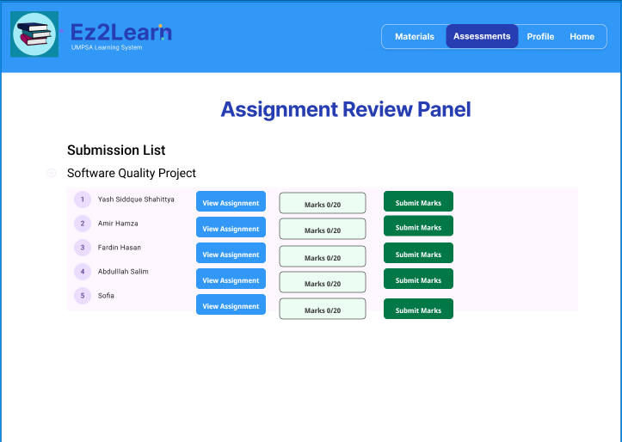

In this module, lecturers can view a list of students who have submitted their assignments for a specific course. Teachers can view each student's submission from this page, review the work that has been submitted, and calculate grades based on that assessment.

Conclusion
In conclusion, the development of the Ez2Learn platform aims to overcome the main challenges faced by students and lecturers at Universiti Malaysia Pahang Al-Sultan Abdullah (UMPSA) in accessing structured and high-quality online learning materials. By providing a centralized and user-friendly e-learning system, Ez2Learn will make learning more flexible, accessible, and engaging for all users.
The platform’s four key modules, which is User Management, Learning Materials Management, Assignment Management, and Progress Tracking work together to create a complete digital learning environment. Students will be able to easily access courses, complete assignments, and track their progress, while lecturers can efficiently manage course materials and monitor student performance.
Using the Agile Scrum methodology, the project promotes teamwork, continuous improvement, and adaptability, ensuring that the system meets software quality standards such as usability, reliability, and maintainability.
Overall, Ez2Learn is designed not only as a functional e-learning system but also as a long-term solution that encourages continuous learning, supports academic growth, and enhances the overall learning experience at UMPSA.

References

- J. Pócsová, D. Bednárová, G. Bogdanovská, and A. Mojžišová, “Implementation of agile methodologies in an engineering course,” Educ Sci (Basel), vol. 10, no. 11, 2020, doi: 10.3390/educsci1011033

- B. Carvalho, C. Henrique, and C. Mello, “Scrum agile product development method—literature review, analysis and classification,” Product: Management & Development, vol. 9, pp. 39–49, 2011, doi: 10.4322/pmd.2011.005

- https://www.figma.com/design/EcLtbyWiYnpvTQ1hOyj8o7/ez2learn?node-id=0-1&t=p1xPIMSGPuslro

Software Quality Assurance Plan (SQAP)

2.1 Purpose and Scope
The purpose of this Software Quality Assurance Plan is to make sure that the Manage Assignments & Assessments module from the Ez2Learn system meets its required requirements and also maintains the quality of the system. The expected outcome from the system is that it is reliable, secure, modular and aligned with its users’ expectations.
This SQAP's scope is to complete all SQA tasks with the module's design, development, and testing. It includes the CRUD operation, which is creating, reading, updating, and deleting assignments and related data for both lecturers and students. The overall plan is that data integrity, confidentiality, and modularity are maintained throughout the entire software lifecycle. This SQAP maintains the structure and requirements of IEEE Std 730.

Definitions and Acronyms

Acronym | Definition
SQA | Software Quality Assurance
SQAP | Software Quality Assurance Plan
IEEE | Institute of Electrical and Electronics Engineers
CRUD | Create, Read, Update, Delete operations
QA | Quality Assurance

Reference Documents
- IEEE Std 730-2014, IEEE Standard for Software Quality Assurance Processes.

- Sommerville, I., Software Engineering, 10th Edition, Pearson, 2016. Available: https://library.uniq.edu.iq/storage/books/file/GlobAl_EdiTioN_Software_Engineering_TENT/1666078186GlobAl_EdiTioN_Software_Engineering_TENT.pdf

- R. S. Pressman and B. R. Maxim, Software Engineering: A Practitioner’s Approach, 9th ed., New York, NY, USA: McGraw-Hill Education, 2020. Available: https://www.researchgate.net/publication/365946272_Software_Engineering_A_Practitioner’s_Approach_9_th_Edition

SQA Plan Overview
The SQA Plan verifies that specified quality requirements have been fulfilled throughout the development and maintenance of the Manage Assignments & Assessments module.

Organisation and Independence

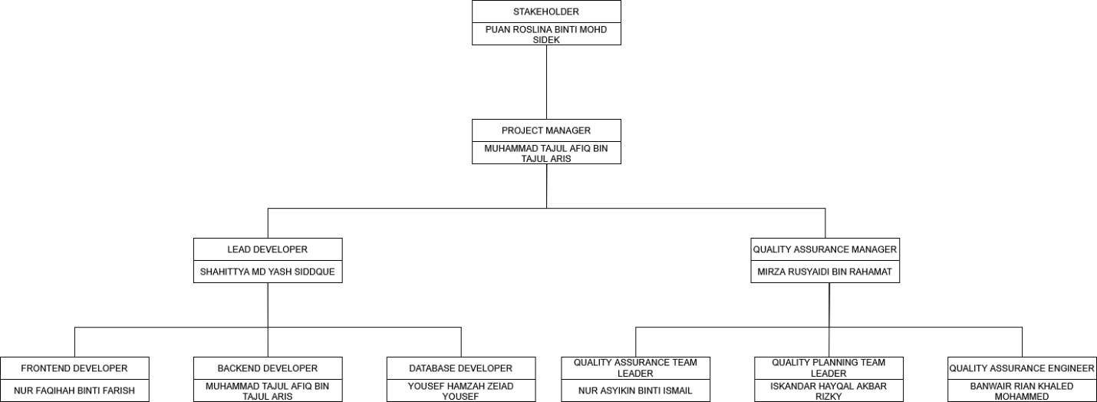

The Manage Assignments & Assessments module's Software Quality Assurance team works independently in the project structure to ensure that the project quality objective is unbiased and aligned with the project objective.

Project Quality Manager
Audit Report/QA Feedback
SQA Team
Project Manager ─> Development Team ─> Testing Team

In this project,
- The SQA team is not involved in code development or implementation activities.

- The SQA Officer or assigned QA personnel who are not directly involved in developing the artefacts under review conduct all reviews, audits, and quality checks.

- The Project Supervisor and Project Quality Manager received audit results and quality reports for review and improvement measures.

At the top of the structure, Puan Roslina binti Mohd Sidek serves as the Stakeholder, providing overall supervision, direction, and approval for the project outcomes. Reporting directly to her is Muhammad Tajul Afiq bin Tajul Aris, the Project Manager, who oversees all development and QA activities, coordinates team communication, and ensures that the project meets its quality and timeline objectives. The Development Team, led by Shahittya Md Yash Siddque as the Lead Developer, handles system implementation and technical tasks. Supporting roles include Nur Faqihah Binti Farish as Frontend Developer, Muhammad Tajul Afiq bin Tajul Aris as Backend Developer, and Yousef Hamzah Zeiad Yousef as Database Developer. Together, they ensure the module is functional, secure, and efficient. The Quality Assurance Team, led by Mirza Rusyaidi Bin Rahamat as the QA Manager, ensures that all deliverables meet IEEE 730 and ISO/IEC 25010 standards.
Supporting roles include Nur Asyikin Binti Ismail as QA Team Leader, Iskandar Hayqal Akbar Rizky as Quality Planning Team Leader, and Banwair Rian Khaled Mohammed as QA Engineer. This team independently verifies and validates the system to maintain high-quality performance and security.

Software Product Risk

Risk | Risk Description | Possible Effect on Quality
Data Loss or Corruption | Database errors or accidental deletion during updates. | Loss of student submissions or grades (affects Integrity).
Unauthorized Access | Weak login or access control. | Confidential student and lecturer data could be exposed (affects Confidentiality).
Module Failure | Code changes in one CRUD function affect others. | System crashes or wrong output (affects Modularity)

Tools

- Documentation: Google Docs and Excel for defect tracking.
- Version Control: GitHub for code tracking.
- Testing Tools: Burp Suite

Tools
This section explains the common rules and methods that everyone in the project must follow to make sure the Manage Assignments & Assessments module is developed with good quality and consistency.

Coding
- Developers must follow a clear and consistent coding style.
- Use simple and meaningful names for files, variables, and functions
- Write short comments in the code to explain the function of that line or part is.
- Use reusable functions or modules

Version Control and Teamwork
- The source code must be stored in GitHub.
- Every update must be reviewed by another team member before it is added to the main branch.
- New features should be done in a separate git branch.

Testing Practices
- Unit tests: test small parts of the code.
- Integration tests: test how modules work together.
- System tests: test the whole module as a complete system.

Documentation
- Create simple user guides for lecturers and students.
- Add system diagrams to show how parts function together.
- Every function or feature should have short written documentation for future maintenance.

Effort, Resources, and Schedule
The project is small and will be completed by a team of 3–4 members. To guarantee that quality requirements are fulfilled, extra time will be given to the testing and review stages.
Resource Type | Description
Human Resources | Project Manager, SQA Officer, Developers, Tester.
Software Tools | Visual Studio, GitHub, Google Docs

Schedule,

Week | Task | Responsible Person | Deliverable
Week 1 | Requirement review and SQA plan preparation | Project Manager, SQA Officer | SQAP draft
Week 2 | System design | Developer | Design document
Week 3 | CRUD functions | Developer | Working prototype
Week 4 | Testing | Tester, QA Officer | Test reporter
Week 5 | Audit, bug fixing, and re-testing | QA Officer, Developer | Audit report
Week 6 | Final review and submission | Project Manager, QA Officer | Final module

Activities, Outcomes, and Tasks

This section describes the main quality assurance activities, expected outcomes, and related tasks for the Manage Assignments and Assessments module.
The activities ensure that the module maintains Integrity, Confidentiality, and Modularity throughout its development and testing processes.

2.5.1 Product Assurance
The Manage Assignments & Assessments module maintains its Integrity, Confidentiality, and Modularity standards because of Product Assurance. It involves reviewing the design, code, and tests, ensuring the security of student and instructor data, and confirming that features like assignment submission and independent grading are functional.

2.5.1.1 Evaluate plans for conformance
Purpose
To make sure the project and test plans follow quality standards and university rules.

Outcomes
- Plans follow authorized QA steps.
- Security controls are complete and practical.
Tasks
- Review of quality and security plans.
- Verify that integration plans maintain module independence.

2.5.1.2 Evaluate Product for Conformance
To confirm that the finished module works as required and keeps data safe.
Purpose
To confirm that the finished module works as required and keeps data safe.
Outcomes
- Every functional and security test is passed by the module.
- There are no data leaks or illegal access.
- Module parts work together without errors.
Tasks
- For assignment and assessment, run integration and unit tests.
- Check file uploads for size restrictions.
- Confirm that module boundaries remain independent

2.5.1.3 Evaluate Plans for Acceptability
Purpose
To confirm that quality plans meet stakeholder needs.
Outcomes
- Stakeholders approve of the quality and test plans.
- Expectations for integrity and confidentiality are fulfilled.

Tasks
- Arrange review meetings with QA and development teams.
- Update test and quality plans from meeting feedback.

2. 5.1.4 Evaluate Life-Cycle Processes for Conformance
Purpose
To ensure all software development steps follow project standards.
Outcomes
- All life-cycle steps follow QA standards.
- Data remain consistent and protected.
Tasks
- Check design and test documents.
- Verify change control and version tracking records.
- Make sure updates do not alter other modules.

2. 5.1.5 Measure Products
Purpose
To measure software quality and performance.
Outcomes
- Measurable data about module quality.
- Marked areas that need improvement.
Tasks
- Record the number of passed and failed tests.
- Measure loading speed and defect numbers.
- Track any security incidents.

2.5.2 Process Assurance Activities
This section describes how the project team will ensure that all methods used to create, test, and maintain the Manage Assignments & Assessments module align with the approved SQA plan and fulfil the objectives of Modularity, Integrity, and Confidentiality.
Process assurance helps confirm that all project activities are done correctly, safely, and effectively. It includes checking how work is done, the tools used, and the skills of the people involved.

2.5.2.1 Evaluate Life Cycle Processes for Conformance
Purpose:
To make sure that every stage of the software life cycle follows the approved quality processes.
Outcomes:
- All project stages follow the agreed standards and processes.
- Any problems or gaps are reported as non-conformities.
- Each update or change maintains module independence and protects user data.
Tasks
- Review the project life cycle plan to ensure it matches quality goals.
- Confirm that changes in the module do not break other modules.
- Document all non-conformities and proper actions.

2.5.2.2 Evaluate Life Cycle Processes for Conformance
Purpose:
To verify that the environments used for software development and testing are appropriate, safe, and aligned with the project's guidelines.
Outcomes:
- Every environment satisfies security and privacy requirements.
- Tools and platforms are configured to protect assignment and grading data.
- Environment setup issues have been recorded and resolved.
Tasks
- Review access permissions for developers and testers.
- Ensure that all tools used support modular development and testing.

2.5.2.3 Evaluate Subcontractor or External Processes for Conformance
Purpose:
To ensure that any external tools or services maintain the same quality and security standards as the project.
Outcomes:
- External tools follow the same security and modularity standards as the main system.
- No external system introduces risk to the system.
Tasks:
- Check that API and other services use secure communication.
- Verify that any third-party tools used in the system handle data safely.
- Module connections with external systems remain separate and well-documented.

2.5.2.4 Measure Processes
Propose:
To measure how effective and consistent the software development processes are.
Outcome:
- Clear, measurable data about system function performance.
- Improved understanding of how modular design supports system quality
Tasks:
- Measure test coverage.
- Record time taken to fix bugs and deploy changes.
- Review process results after each iteration to plan improvements.

2.5.2.5 Assess Staff Skill and Knowledge
Purpose:
To ensure that all team members have the necessary skills and knowledge to perform their tasks correctly and securely.
Outcome:
- Track each team member’s understanding of data integrity, confidentiality, and modularity principles.
- Provide training sessions on secure coding and data handling.
Tasks:
- Review each team member’s experience.
- Keep a record of all training sessions.
- Reassess skills whenever new tools or methods are introduced.

2.6 Additional Consideration

2.6.1 Contract Review
Before development starts, the contract review makes sure that all project requirements and responsibilities for the Manage Assignments & Assessments module are clear. To verify that Integrity, Confidentiality, and Modularity are defined and acceptable, the SQA team reviews the project concept, objectives, and quality goals.

2.6.2 Quality Measurement
To decide how the Manage Assignments & Assessments module's quality will be measured and monitored, making sure that the requirements for Integrity, Confidentiality, and Modularity are met.
Metric | Description / Purpose | Target | Responsible Person
Defect Density | Number of errors per 1000 lines of code. | < 1 defect / 1000 LOC | Tester, QA Officer
Test Coverage | Percentage of code tested during QA. | ≥ 90% | QA Officer
Data Integrity Rate | Accuracy and consistency of stored assignment data. | 100% consistency | Developer, QA Officer
Access Control Test Pass Rate | Percentage of passed authentication tests. | 100% | Tester
Module Independence | Number of issues caused by module interaction. | 0 regression errors | Developer

2.6.3 Waivers and Deviations
If any change or exception to the approved SQAP or project plan is required, it must be reviewed and approved before implementation. For instance, the Project Manager and SQA Officer evaluate the effects on Integrity, Confidentiality, and Modularity if time limitations force delaying a complete regression test. The SQAP change log contains a record of approved modifications. This ensures transparency and prevents uncontrolled modifications that could lower software quality.

2.6.4 Task Repetition
A test or quality activity is repeated until satisfactory results can be achieved if it doesn't meet goals. If a problem is discovered, tasks including assignment upload testing, access-control checks, and grade validation are repeated. These reviews are coordinated by the QA Officer, who also ensures that the fixes do not result in new faults. This repetition ensures that data remains consistent, permissions secure, and module components stable before release.

2.6.5 Risks in Performing SQA
Performing SQA activities may face real-world risks such as limited testing time, inconsistent internet connectivity, lack of anonymized test data, or miscommunication between team members. These risks could lead to incomplete security testing or missed integrity checks. To reduce them, the team schedules buffer days for QA, keeps secure backups of all data, and uses automated testing tools to save time. High-priority risks are discussed weekly, and mitigation steps are recorded in the risk log.

2.6.6 Communication Strategy
Effective communication keeps everyone aligned with quality goals. Weekly meetings between the Project Manager, Developer, and SQA Officer review progress, defects, and upcoming audits. Critical problems, such as breaches of access control or data integrity, are notified right away by email or group chat. All task items and meeting summaries are stored in shared project files. During development, this open communication guarantees quick problem-solving and responsibility.

2.6.7 Non-Conformance Process
A product or procedure is labelled as non-conforming when it does not satisfy a requirement, such as improper data management, broken linkages, or missing access control. The Project Manager assigns a responsible team member to fix the problem when the SQA Officer reports it to them. The SQA team retests the affected module following the fix to confirm resolution. The defect-tracking file contains documentation of all non-conformances, actions, and results. This procedure guarantees that every issue is appropriately fixed and that overall system quality keeps getting better.

2.7 SQA Records

2.7.1 Analyze, Identify, Collect, File, Maintain, and Dispose
This part explains how quality records are handled in the Manage Assignments & Assessments module. Quality records include test results, review forms, error reports, and feedback files. These records show that all work follows the project plan and quality rules. All records are collected by the SQA Officer and kept in a secure folder with unique names and dates. This keeps information accessible and well-organized. Until the project is completed, the recordings remain available. After that, outdated or unnecessary files are securely removed to maintain confidentiality. The team may monitor progress, identify issues early, and enhance the system's integrity and modularity by keeping these data.

2.7.2 Availability of Records
All project records are shared only with people who are allowed to see them, such as the project supervisor, SQA Officer, and developer. To maintain confidentiality and integrity, the files are stored in a shared folder with restricted access. When necessary, the project manager ensures that all test results, reports, and quality documents are available. The SQA Officer ensures that no one modifies or removes the records without authorization. This process facilitates quality evaluations or audits and maintains project transparency.

3. Software Quality Assurance Design

Abstract
The purpose of this Software Quality Attribute Design (SQAD) document is to explain the important quality attributes chosen for the Ez2Learn Manage Assignments & Assessments module. This module is an important part of the system because it allows lecturers to create assignments, students to submit their work, and lecturers to grade and manage assessments. The module handles sensitive academic information such as assignment files, student submissions, and marks must always maintain high-quality standards.
This SQAD focuses on three main quality attributes for module 3 is Integrity, Confidentiality, and Modularity. These attributes were chosen because they help protect data from unwanted changes, prevent unauthorised access, and ensure that each part of the module works independently without affecting other features.
By following the ISO/IEC 25010 quality model and other common software architectural methods, this document helps make sure that Module 3 keeps data accurate, secure, and easy to maintain. [1]

Introduction
This SQAD document explains the important quality aspects planned for the Manage Assignments & Assessments module in the Ez2Learn system. This module handles important academic tasks, including assignment uploads, deadline management, grading workflows, submit assignments and student–lecturer interactions.
The SQAD's main goal is to identify and explain the quality attributes which impact the design of SQAD's module. These attributes are selected to meet the expectations of stakeholders, including instructors, students, and the university.
They help make sure the module is secure, reliable, and easy to maintain. The chosen quality attributes, simple examples of how each attribute is applied, and tactics used to support these attributes are all included in this document [2].
The module architecture is redesigned in this SQAD paper with an emphasis on:
- Ensuring high data security for grades and academic submissions.
- Maintaining system reliability and correctness throughout assignment workflows.
- Organizing module elements to make them reusable, independent, and maintainable.

Background of study
Universities around the world are increasingly relying on digital tools to manage their academic tasks. Because of this change, a lot of educational institutions are switching to combined e-learning platforms that facilitate both online and hybrid learning. These platforms need to handle important tasks such as giving out assignments, collecting student submissions, grading, and sharing feedback between instructors and students.
The Ez2Learn platform was created to bring all these activities together in one place for UMPSA students. Module 3, the “Manage Assignments & Assessments” module, is important because it helps lecturers and students manage assignment deadlines, upload and store academic files, and keep all records accurate.
Module 3 concentrates on resolving many important issues, like:
- Stopping anyone from changing grades or damaging data without permission.
- Keeping student submissions private and protected.
- Making the system easier to update and maintain in the future.
- Reducing errors that happen when parts of the code rely too much on each other.
Since data security and academic integrity are essential in higher education, this module needs to be developed with advanced features. Important features like security, reliability, and maintainability are highlighted by standards like ISO/IEC 25010:2011, which are essential for any system managing academic data. [3]

Introduction to Quality Attributes
Quality attributes show how well a system works, not just what it does. While quality attributes describe how the system performs in various scenarios, functional requirements tell us what the system should do.
For the Manage Assignments & Assessments module, three attributes are identified as important,

INTEGRITY
In this module, integrity means keeping academic information correct, consistent, and secure from unauthorized changes [4]. Only authorized individual users are allowed to make any change to student submissions, grades, assignment files, instructions, or due dates in module 3. Integrity ensures that academic data, grades, submissions, and deadlines remain,
- Accurate
- Consistent
- Protected from unauthorized modifications.

CONFIDENTIALITY
In this module, confidentiality means keeping sensitive academic data safe from people who shouldn’t see it. Access must be restricted because student submissions and assignments may contain personal data. This information should only be read or modified by approved users, like lecturers or students. Confidentiality ensures that sensitive academic information is not disclosed to unauthorized parties.
For instance,
- Student submissions
- Grading feedback
- Assessment metadata and so on

MODULARITY
In this module, modularity means dividing different modules into separate parts, like assignment creation, submission handling, grading, and others, so that changes in one part don’t affect the others. This makes the system easier to maintain, reduces errors, and allows updates to be done more easily in the future. Modularity focuses on structuring the system into well-defined components, like:
For instance,
- Student submissions
- Grading feedback
- Assessment metadata and so on

QUALITY ATTRIBUTE SCENARIOS

INTEGRITY SCENARIO

A lecturer updates a student’s assignment marks within the Manage Assignments & Assessments module. The system confirms that the lecturer has the proper authorization to change grades for the relevant course and assignment before saving the modifications. After checking, the updated grade is safely stored and stored in the database. Any attempts by unauthorized users—such as students or lecturers from other sections to alter grades are immediately rejected based on the system’s predefined access rules.

- Source: Authorized lecturer
- Stimulus: Request to submit or update a grade
- Environment: Normal system operation
- Response: The system should save the new grade, check permissions, and block any unauthorized changes.
- Response Measure: The grade is updated correctly within 2 seconds, with 100% prevention of unauthorized modifications, and unauthorized changes are blocked.

CONFIDENTIALITY SCENARIO
By manually changing the URL or the submission ID in the system's address bar, a logged-in student tries to access another student's assignment file.The system detects that the student’s identity and access permissions do not match the requested submission. As a result, the system immediately denies the request, ensuring that the unauthorized user cannot view, download, or infer any information related to the protected assignment.The file can only be accessed by the authorized instructor and the legitimate submission owner.

- Source: Logged-in student
- Stimulus: Unauthorized access attempt by changing IDs
- Environment: Normal system use
Response: The system blocks access to the file, prevents exposure of any submission details, and does not reveal any information. Only the submission owner and the lecturer can view the file.
- Response Measure: Access is blocked immediately, and no data is leaked.

MODULARITY SCENARIO

A developer updates the assignment deadline feature within the Manage Assignments & Assessments module to introduce automated reminder notifications for students. The system architecture makes sure that modifications are limited to the deadline submodule during the update. The grading workflow, submission storage logic, and assignment creation components remain unaffected due to proper modular separation and encapsulation.

- Source: Development team
- Stimulus: Updating the deadline feature
- Environment: Development and integration testing
- Response: Only the deadline module is changed, and all other modules of the system should continue working normally with no new errors.
- Response Measure: No failures happen in other modules during testing. Regression tests should show 100% success for components not related to the update.

TACTICS FOR THE QUALITY ATTRIBUTES

INTEGRITY TACTICS

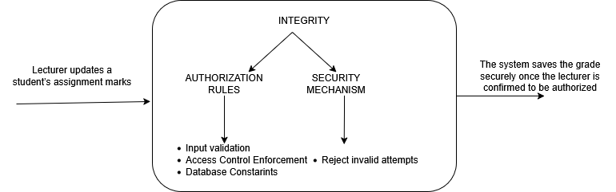

- Input Validation: Need to make sure only correct and expected data is saved or taken as input in the system.
- Access Control Enforcement: Only authorized lecturers are allowed to change grades, assignments and so on.
- Database Constraints: Using foreign keys, unique IDs, and proper transactions to stop incorrect or unauthorized changes.

CONFIDENTIALITY TACTICS

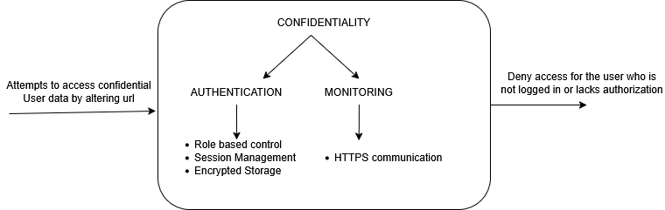

- Role-Based Access Control: Only the authorized users can view or access certain data.
- Encrypted Storage: Student submissions might saved in an encrypted form so unauthorised users cannot read them.
- HTTPS Communication: Protects data sent between the user and the server from being intercepted.
- Session Management: Ensures that only logged-in and verified users can perform sensitive actions.

MODULARITY TACTICS

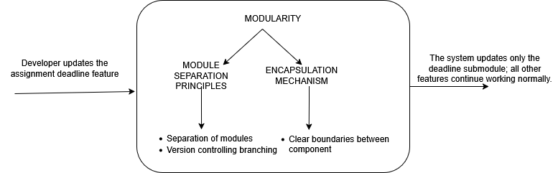

- Separation of Modules: Different features like submission, grading, and deadlines are kept in separate modules.
- Encapsulation: Each module hides its internal logic so other modules can’t interfere with it.
- Version Control Branching: Using feature branches which helps avoid accidental changes to other parts of the system.

CONCLUSION
The Manage Assignments & Assessments module in Ez2Learn is designed with a quality focus according to this SQAD guideline. It highlights three key areas, Integrity, Confidentiality, and Modularity, to make sure academic data stays correct, protected, and easy to maintain. Through enhanced Integrity, Confidentiality, and Modularity mechanisms, the system ensures that academic data remains trustworthy, secure, and maintainable. The included scenarios, tactics, and architectural structures allow developers, testers, and stakeholders to maintain long-term reliability and extensibility while supporting a secure digital learning environment.
This document serves as a reference for developers, testers, and stakeholders, ensuring that the module’s design remains consistent with institutional expectations and software engineering best practices.

REFERENCES

- E. Trichkova-Kashamova, "Applying the ISO/IEC 25010 Quality Models to an Assessment Approach for Information Systems," 2021 12th National Conference with International Participation (ELECTRONICA), Sofia, Bulgaria, 2021, pp. 1-4, doi: 10.1109/ELECTRONICA52725.2021.9513662

- Bohutskyi, S. (2023). Quality Attribute Tactics: Strategies for building more robust and efficient systems. Available: https://blog.bitsrc.io

- Estdale, John & Georgiadou, Elli. (2018). Applying the ISO/IEC 25010 Quality Models to Software Product: 25th European Conference, EuroSPI 2018, Bilbao, Spain, September 5-7, 2018, Proceedings. 10.1007/978-3-319-97925-0_42.

- Clements, P., Bachmann, F., Bass, L., & Merson, P. (2010). Quality Attribute Workshop Handbook. CMU/SEI-2008-HB-002. Software Engineering Institute.

4. Implementation

4.1 Module Implementation Overview

The Manage Assignments & Assessments module is implemented as a web-based component to the Ez2Learn system, which uses PHP for backend logic, MySQL for database management, and HTML, CSS, and JavaScript for the frontend interface.
This module helps with the basic tasks of managing assignments and assessments, like creating, reading, updating, and deleting (CRUD) them. This module supports the core CRUD operations required for managing assignments and assessments while ensuring Integrity, Confidentiality, and Modularity as defined in the SQAP.
The module is designed to be modular. This means this module, Manage Assignments & Assessments, is kept separate from other parts of the system, such as User Management or Learning Materials. This approach makes the system easier to develop, maintain, and reduce errors.

4.2 Methodology

The development of the Ez2Learn system follows the Agile Scrum methodology. Agile Scrum is perfect and works well for this project because it supports incremental development, continuous testing, and regular feedback, which contributes to ensuring software quality attributes such as Integrity, Confidentiality, and Modularity.
Instead of developing the entire system in a single sprint, the module is built in multiple iterations. Each sprint or iteration focuses on implementing, testing, and reviewing a specific set of features related to the module assignment and assessment management.
The Agile Scrum methodology used in this project consists of the following phases:

4.2.1 Requirement Analysis Phase
This phase involves identifying and analyzing the Manage Assignments & Assessments module's functional and non-functional requirements. The requirements are gathered based on:
- Lecturer and student needs
- Project objectives
- Software Quality Assurance (SQA) requirements
Key requirements identified include:
- Assignment creation, submission, grading, and deletion
- Secure access based on user roles
- Data accuracy and protection
- Independent module operation

4.2.2 System Design Phase
During the design phase, the overall system architecture is planned. This includes:
- Database design for assignments, submissions, and grades
- Separation of backend logic and frontend interface
- Definition of module boundaries to implement modularity
Design decisions are made to ensure:
- Data integrity through proper database relationships
- Confidential access through role-based design
- Modularity by separating assignment-related components from other system modules

4.2.3 Implementation Phase
In the implementation phase, the actual development of the module starts. The system is developed using:
- PHP for backend processing
- MySQL for database management
- HTML, CSS, and JavaScript for the frontend interface
The implementation follows a modular structure where each function, such as assignment creation, submission, and grading, is developed separately.

4.2.4 Testing Phase
Testing is carried out continuously throughout each sprint. This phase ensures that the module functions correctly and meets its quality requirements.
Types of testing include:
- Unit testing to verify individual functions
- Integration testing to ensure interaction between system components
- Security testing to validate access control and data protection
Testing activities focus on confirming that:
- Data is stored and retrieved accurately
- Unauthorized access is not allowed
- Module changes do not affect other system components

4.2.5 Review and Evaluation Phase
At the end of each sprint, the functions of the system are reviewed by the development and QA teams.
Feedback is collected to identify:
- Functional issues
- Security weaknesses
- Design improvements

4.2.6 Deployment Phase
After successful testing and review, the module is deployed in a development environment. This phase allows final verification of:
- System stability
- Data handling accuracy
- User interaction flow

4.2.7 Maintenance and Improvement Phase
In this final phase, the module is monitored for defects or enhancement opportunities. Bug fixes, minor improvements, and optimizations are performed without affecting other modules due to the system’s modular design.

4.3 Tools
Tool | Purpose
XAMPP | Provides a local server environment for developing and testing the application
PHP | Implements backend logic, handles CRUD operations, and enforces access control.
MySQL | Stores and manages assignment, submission, and assessment data securely.
HTML & CSS | Designs and structures the user interface for lecturers and students.
JavaScript | Performs client-side validation and enhances user interaction.
GitHub | Manages version control, collaboration, and code change tracking.
Google Docs / Excel | Prepares documentation, test cases, and defect tracking records
Microsoft Word | Produces formal project reports.
draw.io | Creates system diagrams, flowcharts, and module design illustrations
Figma | Designs and prototypes user interface layouts for the Ez2Learn platform.

